Case 8-CAN-NWC-Totem Pole-Eagle-Bear

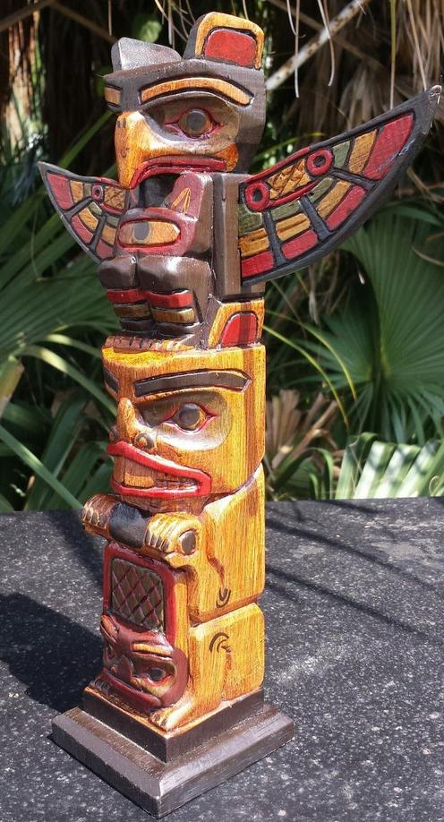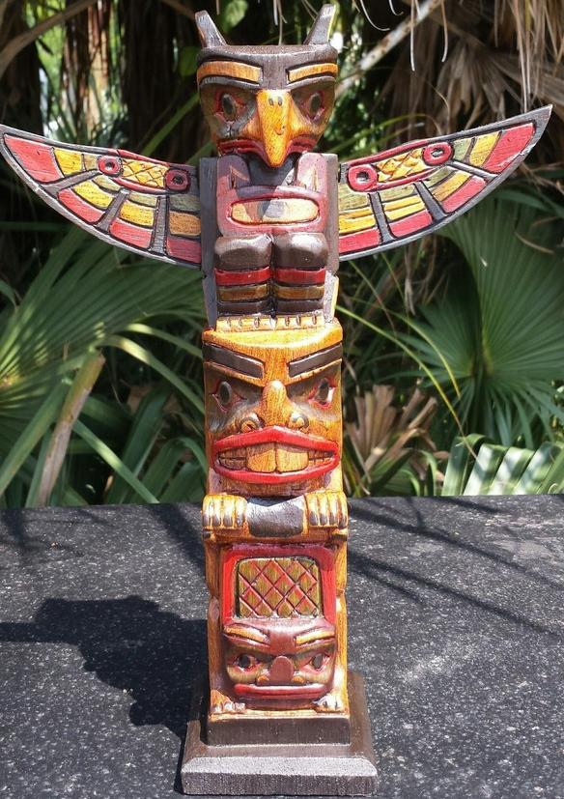
12" LONG X 3 INCH WIDE AT BASE & 10 INCH WINGSPAN
